Engineered Synthetic Organ Can Produce B Cells 100 Times Faster

By Abubaker Zahoor on June 13, 2015

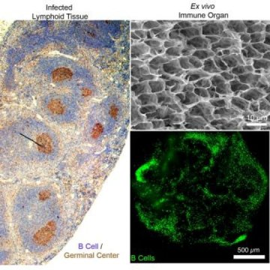
Engineers at Cornell university have successfully created a functional, synthetic immune organ that can give birth to antibodies. The most important characteristic of this organ is that it can exist without any living organism in the lab, where engineers can control it themselves.
The engineered synthetic organ is first of its kind. The innovative idea was made by Ankur Singh, assistant professor of mechanical and aerospace engineering. Mr Singh makes use of his engineering knowledge in the study of the human immune system.
To make the immune organoid, engineers used gelatin-based biomaterials. They reinforced biomaterials with nanoparticles before seeding them with cells. The anatomical environment of the organ is rather imitation of that of lymphoid tissue.
“Like a real organ, the organoid converts B cells — which make antibodies that respond to infectious invaders — into germinal centers, which are clusters of B cells that activate, mature and mutate their antibody genes when the body is under attack.
“Germinal centers are a sign of infection and are not present in healthy immune organs,”ScienceDaily explains.
The engineers have shown off how they can control the immune responsiveness in the organ. The demonstration also included the adjustment of proliferation of the B cells. The successful engineers believe that their purposed method can lead to 100 times rapid production of the B cells.
“You can use our system to force the production of immunotherapeutics at much faster rates,” said Singh.
The complete description of the project can be accessed in the online journal Biomaterials.

